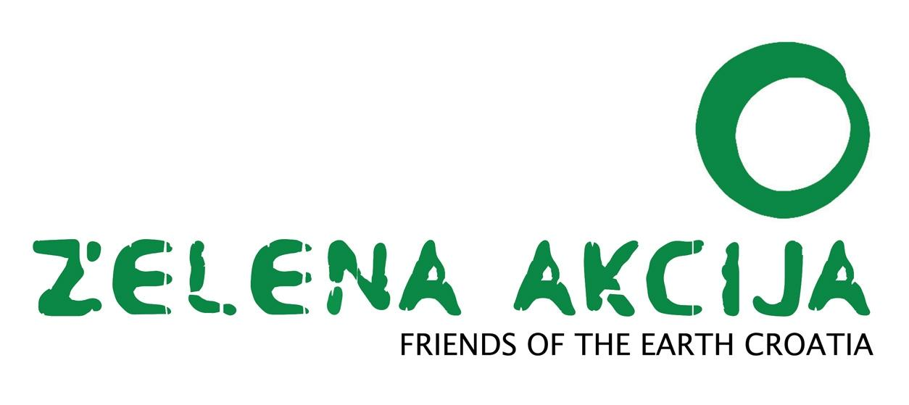
Zagreb, 5/5/2023

CLIMATE DEMANDS

1. We are asking the Government of the Republic of Croatia for a green and just new plan for Croatia

The climate crisis is a great threat to humanity, but we must also recognise the moments to build a more sustainable and fair society. A green and just new plan for Croatia must be based not only on green policies, but it must also integrate socioeconomic rights that will, at the same time, encourage the fight against various types of social inequality and poverty.

Therefore, it is necessary:
- plan to suspend all investments in the fossil fuel industry: stop the increase of the capacity of the Krk LNG terminal and the construction of new gas pipelines, close the coal power plant Plomin 2 until 2026, not allow exploration and exploitation of gas and oil in Croatia after 2035, gradually phase-out gas in the heating and electricity sectors by 2035 and after that in industry etc.

- stop subsidising fossil fuels, and redirect the the budget to mass promotion of energy efficiency, renewable energy sources, accompanying research and development, and the fight against energy poverty

- improve all climate-energy policies, starting with the National Energy and Climate Plan and the Low-Carbon Development Strategy of the Republic of Croatia, which implies the creation of a plan to reduce greenhouse gas emissions to zero by 2050 at the latest, and complete removal of measures, research and developmental directions involving fossil fuels

- enable and encourage citizens and communities of citizens to be active participants in the energy transition

- to provide people with the possibility of self-sufficiency, energy production and association in communities of energy producers, taking into account not only the legislative framework in the field of energy, but also the barriers arising from other laws

- create a plan for the democratisation and decentralisation of the energy system so that energy is really in the hands of the people of this country, not corporations and influential individuals
- invest in sustainable transport and encourage sustainable mobility, ensuring adequate and accessible public transportation, especially in the segment of rail transport infrastructure modernisation; create cities in which a significant number of daily needs for migration will be able to be met by non-motorised types of transport and thereby reduce the share of car trips; invest in supporting infrastructure for the development of ecological mobility and encourage the transition to ecological mobility and alternative fuels (which do not include fossil gas)

- encourage and promote the development of a green and sustainable industry by creating the necessary preconditions for the withdrawal of available EU funds through urgent adaptation and refinement of national laws and strategies

- create a plan at the state level for a just transition in polluting industry sectors, which means transforming the economy fairly and inclusively to ensure the maintenance and creation of green, quality and decentjobs; the transition to a green economy that is just for ALL workers and that does not destroy, but preserve and create good and quality jobs should be ensured; it is necessary to anticipate and manage the transition and negotiate with workers in every aspect that concerns them, such as the need for new skills and the right to quality training and lifelong learning for every worker

- encourage local and ecological food production as a low-carbon measure and a measure of adaptation to the impacts of the already inevitable climate change, which brings instability of the food supply, and in this way, sustainably use Croatia's natural resources and contribute to health and well-being

- enable regional and local self-government units to implement and invest in measures that will ensure adequate adaptation to those effects of climate change that are already inevitable, including infrastructure, services and education of citizens, based mainly on green solutions, while encouraging them to turn towards low-carbon development and the future

- create a strategy to combat energy poverty, including its legal definition and categorisation; adopt official plans at local levels so that they can be systematically monitored and adequately approached to solve the problem

- redirect part of the funds invested in the militarisation of borders and the military industry - the military budget has grown to 1 -1.1 billion euros per year, i.e. about 270 euros per inhabitant - towards climate change mitigation measures, climate change adaptation measures and socioeconomic measures that will help all residents of this country, regardless of where they came from

- actively involve young people in the creation of policies that concern them and their future; young people are not part of the discussion on the green transition, and strategic documents in the field of young people do not recognise the seriousness of the situation. However, European and national research shows that the concern for the climate and the environment is among the top priorities for young people.

2. We are asking the Croatian Parliament for a symbolic declaration of a climate change state of emergency or climate crisis

Considering recently published report of the Intergovernmental Panel on Climate Change (IPCC), which clearly indicates an alarming situation at the global level, and taking into account the adoption of the resolution of the European Parliament in 2019 declaring a climate and environmental crisis in Europe and the world, we demand that Croatia symbolically declares a climate emergency. The resolution mentioned above calls for fast, ambitious and coordinated actions at the European and global levels to reduce greenhouse gas emissions and limit the growth of the average global temperature to 1.5°C above the pre-industrial level.

We ask that the voice of citizens who are worried about their present and future due to the increasingly intense consequences of climate change are heard more strongly. This is a symbolic level of state of emergency, which in no way means that the Zelena akcija / FoE Croatia calls for any limitation of the constitutionally guaranteed freedoms and rights of citizens.

There is indisputable scientific confirmation that human activities associated with fossil fuels are the cause of climate change and that we are currently faced with severe consequences that include increasingly frequent and intense climate disasters, such as floods, fires, droughts and hurricanes, but also rising sea levels, melting of ice at the poles ect. Such consequences of climate change threaten our health, biodiversity and the quality of life of all people.

Therefore, we call on the Croatian Parliament, as the representative body of the citizens and the holder of the legislative power in Croatia, to take action to urgently reduce greenhouse gas emissions, promote a sustainable way of life, a just transition, protecting natural resources and strengthening resistance to climate change. Declaring a climate emergency or climate crisis would be a strong signal that the government is aware of the situation's urgency and is ready to take all necessary steps in the fight against the climate crisis.

Demands are signed by:

- Zelena akcija / FoE Croatia
- Green Forum
- Society for Designing Sustainable Development
- Green Philosophical Initiative
- Extinction Rebellion Zagreb
- Fridays For Future Croatia
- Union of cyclists
- Center for Peace Studies
- Croatian Youth Network
- fACTIVE (feminist collective)
- Operation City
- Network of anti-fascist Women in Zagreb

